**Project Design Phase-II**

**Data Flow Diagram & User Stories**

|  |  |
| --- | --- |
| Date | 17 October 2022 |
| Team ID | PNT2022TMID47816 |
| Project Name | Project – Inventory Management System for retailers |
| Maximum Marks | 4 Marks |

**Data Flow Diagrams:**

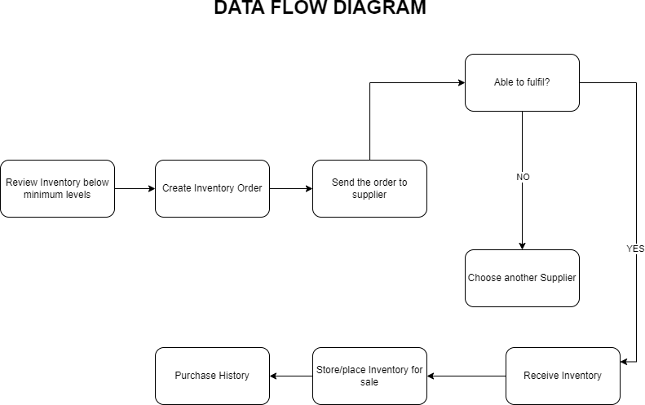

**User Stories**

Use the below template to list all the user stories for the product.

|  |  |  |  |  |  |  |
| --- | --- | --- | --- | --- | --- | --- |
| **User Type** | **Functional**  **Requirement**  **(Epic)** | **User**  **Story**  **Number** | **User Story / Task** | **Acceptance criteria** | **Priority** | **Release** |
| Customer (Mobile user) | Registration | USN-1 | As a user, I can register for the application by entering my email, password, and confirming my password. | I can access my account / dashboard | High | Sprint-1 |
|  |  | USN-2 | As a user, I will receive confirmation email once I have registered for the application | I can receive confirmation email & click confirm | High | Sprint-1 |
|  |  | USN-3 | As a user, I can register for the application through Facebook | I can register & access the dashboard with Facebook  Login | Low | Sprint-3 |
|  |  | USN-4 | As a user, I can register for the application through Gmail | I can register for the application through Gmail | Medium | Sprint-2 |
|  | Login | USN-5 | As a user, I can log into the application by entering email & password | I can log in by  entering  Gmail & password | High | Sprint-1 |
|  | Dashboard | USN-6 | As a user, I can track data of sales of products and inventory levels | I can track data of sales of products and inventory levels. | High | Sprint-1 |
| Customer (Web user) | Registration | USN-7 | As a user, I can register for the application by entering my email, password, and confirming my password. | I can access my account / dashboard | High | Sprint-1 |
|  |  | USN-8 | As a user, I will receive confirmation email once I have registered for the application | I can receive confirmation email & click confirm | High | Sprint-1 |
|  |  | USN-9 | As a user, I can register for the application through Facebook | I can register & access the dashboard with Facebook  Login | Low | Sprint-3 |
|  |  | USN-10 | As a user, I can register for the application through Gmail | I can register for the application through Gmail | Medium | Sprint-2 |
|  | Login | USN-11 | As a user, I can log into the application by entering email & password | I can log in by entering Gmail & password | High | Sprint-1 |
|  | Dashboard | USN-12 | As a user, I can track data of sales of products and inventory levels | I can track data of sales of products and inventory levels. | High | Sprint-1 |
| Customer  Care  Executive | Support | USN-13 | As a Executive, I Provide answers for the queries asked by users. | I provide the answers for the queries asked by the users. | High | Sprint-1 |

|  |  |  |  |  |  |  |
| --- | --- | --- | --- | --- | --- | --- |
| **User Type** | **Functional**  **Requirement**  **(Epic)** | **User**  **Story**  **Number** | **User Story / Task** | **Acceptance criteria** | **Priority** | **Release** |
| Administrator | Manage the Stocks | USN-14 | As a administrator, I manage the stocks by adding, shipping and storing the stocks in the storage units | I manage the stocks by adding, shipping and storing the stocks in the storage units. | High | Sprint-1 |
|  | Control all the users | USN-15 | As a administrator, I can control all the users by performing basic CRUD operations. | I can control all the users by performing basic CRUD  operations | High | Sprint-1 |
|  | Access the database | USN-16 | As a administrator, I can control and access the database | I can control and access the database. | High | Sprint-1 |